PRACTICAL SSIGNMENT
Class X (402)
- Create a Writer Document and write all the steps to do following instructions.
  - Set the indentation Left with 1.5 cm and Right with 1 cm.
  - Set the Portrait orientation and margins values Top = 2.0 cm., Bottom = 2.15 cm., Left
= 2.50 cm., Right = 2.50 cm.
  - Set the paper size A4 (21 cm X 29.7 cm).
  - Set the document border with double line style, red colour, width = 3 pt.
  - Set the document with custom watermark “My Content”.
  - Write First line with Font type = “Arial Black” Size = 12 pt., Font Colour=” Red”, Text highlight colour = “Yellow”, Align = Centre.
  - Write Second line (x+y)2 and H2O and Strikethrough and Double Strikethrough.
  - Next write 5 bulleted list (Any five fruits) with filled square style.
  - Next write 5 Numbered list (Any five Shortcut Keys) with using Capital Roman Number Format.
  - Now change the line spacing of upper written contents with size 1.15 pt.

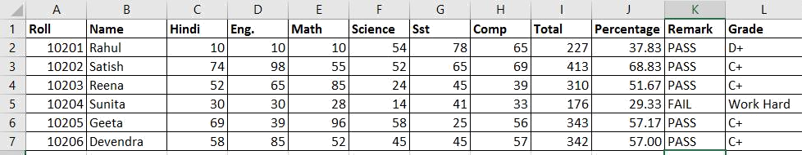
- Create the following excel worksheet: -

  - Write the function to calculate total marks of all subjects (Rahul).
  - Write the function to calculate Percentage of marks of all subjects (Rahul).
  - Write the function to calculate Remark of all subjects (Rahul).
  - Write the function to Grade of total marks of all subjects (Rahul).

Criteria of grade: | >= 90 | A+
 | >= 75 | B+
 | >= 50 | C+
 | >= 33 | D+
 | <33 | Work hard

3). Write an SQL Query to create a table with the following structure: Emp_no char(4), Name varchar(25), Salary Float, Department varchar(15).
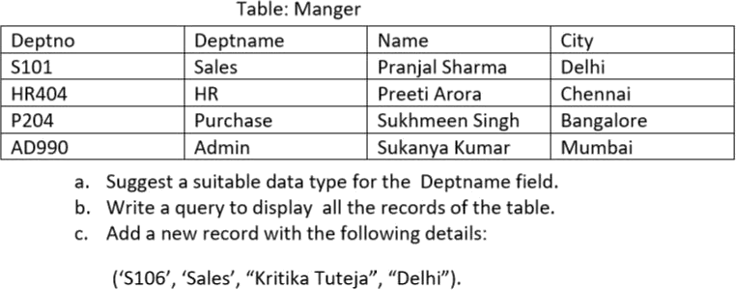
4. Write the answers based on the following table Name Manager:
d) Display department name where city is Chennai
e) Display different cities in the manager table
f) Arrange all the records in ascending order department wise.
g) Change the Deptname HR to Admin HR.

